**Project Design Phase-II**

**Data Flow Diagram & User Stories**

**Data Flow Diagrams:**

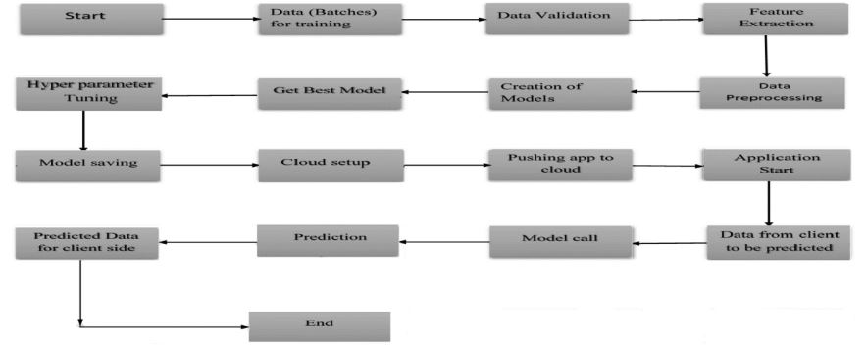

**User Stories**

| **User Type** | **Functional Requirement (Epic)** | **User Story Number** | **User Story / Task** | **Acceptance criteria** | **Priority** | **Release** |
| --- | --- | --- | --- | --- | --- | --- |
| Customer | Registration | USN-1 | As a user, I can register for the application by entering my email, password, and confirming my password. | I can access my account / dashboard | High | Sprint-1 |
|  |  | USN-2 | As a user, I will receive confirmation email once I have registered for the application | I can receive confirmation email & click confirm | High | Sprint-1 |
|  |  | USN-3 | As a user, I can register for the application through Facebook | I can register & access the dashboard with Facebook Login | Low | Sprint-2 |
|  |  | USN-4 | As a user, I can register for the application through Gmail |  | Medium | Sprint-1 |
|  | Login | USN-5 | As a user, I can log into the application by entering email & password |  | High | Sprint-1 |